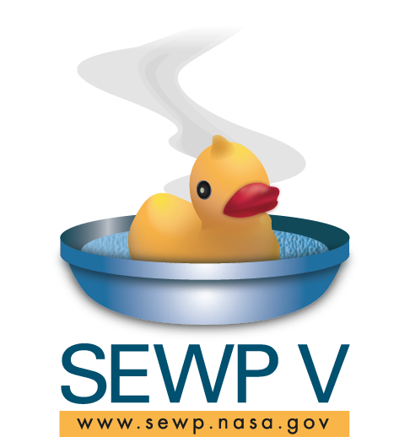

NASA SEWP V
Ordering Guide

Minburn Technology Group, LLC
9716 Arnon Chapel Road
Great Falls, VA 22066
571-699-0705

Contract No. NNG15SD34B

About Minburn Technology Group, LLC
Minburn Technology Group, LLC (“Minburn”) is a Value-Added Reseller of Information Technology Solutions founded in 2010 and focused on U.S. Federal Government and Healthcare markets. Our core competency is supporting complex technical, contracting, and financing transactions for select IT manufacturers. Minburn is certified by the U.S. Department of Veterans Affairs, Center for Veterans Enterprise as a Service-Disabled Veteran-Owned Small Business (SDVOSB), and we are currently registered in the Veterans Affairs VetBiz database.

SEWP V Overview
The NASA SEWP (Solutions for Enterprise-Wide Procurement) GWAC (Government-Wide Acquisition Contract) provides the latest in Information Technology (IT) products and services for all Federal Agencies and their approved contractors. The statutory authority allowing usage of the SEWP contracts by the entire Federal Government is NASA's designation as an Executive Agent by OMB based on the Information Technology Management Reform Act (ITMRA) of 1996, now the Clinger Cohen Act.

The SEWP contracts offer a vast selection and wide range of commercial advanced technology, including:

- Desktops and servers | - Software products
- ICT peripherals | - Cloud based services
- Network equipment | - Telecommunication
- Storage systems | - Health IT
- Security tools | - Video conferencing systems

SEWP also offers product-based services such as installation, maintenance and other services related to in-scope products to all Federal Agencies (including Department of Defense) and their approved support service contractors. SEWP offers low prices and the easiest and fastest quoting and ordering procedures using pre-competed contracts.

All SEWP V Contracts have an effective ordering period of May 1, 2015 through April 30, 2025. The base contracts were awarded for 5 years with one 5 year option for a total of 10 years. Each contract has a $20 Billion contract limit.

How to Obtain a Quote / Fair Opportunity
SEWP V is composed of a suite of Indefinite Delivery Indefinite Quantity (IDIQ) contracts to over 140 pre-competed Prime Contract Holders, both manufacturers and resellers of IT equipment. The contracts were awarded in 5 contract Groups - 2 full and open and 3 set-aside competitions. Since all awards were multi-award contracts, Fair Opportunity (refer to FAR 16.505(b)) must be given to all contractors in one or more Groups or set-asides.
The SEWP website provides the only SEWP recommended tools for manufacturer searches Market Research Tool and for Request for Information/Request for Quotes (RFI/RFQ) (Quote Request Tool). These tools are available to assist customers with buying decisions and as one means to provide documentation for any needed selection criteria. The following steps may assist customers in determining which contract best fulfills their requirements:
- Market Research: According to Federal Acquisition Regulations, (FAR) Part 10, appropriate market research based on the size and complexity of the acquisition is required. The Online Market Research Tool and Quote Request Tool SEWP tools assist in this market research process.
- Fair Opportunity: FAR 16.505(b) (1) provides that each contractor shall be given fair opportunity to be considered for each order exceeding $10,000 and issued under multiple award contracts. The FAR states that the method to obtain fair opportunity is at the discretion of the CO and that the CO must document the rationale for placement and price of each order. Using the SEWP online Quote Request Tool is the recommended method to assist in this activity and to augment the required decision documentation. The SEWP QRT tool will automatically include the Contract Holders within a selected Group or based on a suggested source.
NOTE: Fair Opportunity to all Contract Holders within one or more SEWP Groups or set-asides is required. There is no requirement to obtain 3 quotes as long as all Contract Holders within a Group or set-aside were provided opportunity to provide a quote.
- Best Value: Once market research is completed, the end-user's needs, technical requirements, Contract Holder program performance, price, Agency policy and other factors related to the exercise of sound business judgment should be considered in making a best value determination.

Placing an Order under SEWP V
All Delivery Orders must be routed through the SEWP Program Office (PMO) and should not be sent directly to the contract holder. Once received from the customer, SEWP will log the order and check that the order total matches the verification file from the quote.
SEWP orders can be placed via email or fax:
- Email a .pdf or image file to sewporders@sewp.nasa.gov
- Fax orders and completed forms to (301) 286-0317
SEWP will process your order and assign a SEWP Tracking Number (STN). The SEWP PMO will then send the order to the Contract Holder for processing.

Minburn Quotes, Post-Delivery Procedures, and Order Troubleshooting
For inquiries regarding Minburn’s SEWP V product offerings, or for questions related to post-delivery policies, procedures or order issues, please email info@minburntech.com, or contact:
Stuart Harding
Program Manager
stuart.harding@minburntech.com
208-228-7107 direct
540-683-1801 mobile

