

Technology Group

Information technology built for the

Federal Government

Capabilities Statement

Minburn is a Value-Added Reseller focused on providing enterprise Information Technology solutions. Founded in 2010, Minburn has been verified by the U.S. Department of Veterans Affairs (“VA”), Center for Veterans Enterprise (“CVE”) as a Service- Disabled Veteran-Owned Small Business (“SDVOSB”) concern.

®



**The Open Group**

**Certified**

Self-Assessed Open Trusted Technology Provider™ V1

O-TTPS 1.1.1 (ISO/IEC 20243:2018) Top 100 Largest Government Contractors

At Minburn, we believe that focus is the key to long-term customer satisfaction. Our guiding philosophy is to do a few things exceptionally well rather than many things poorly. As a result, our company is focused on the following four core competencies:

# Core Competencies

## Microsoft Enterprise Software and Cloud Computing Solutions

Our principal core competency is supporting Microsoft Enterprise Agreements and delivering complex Azure cloud computing solutions to US government end customers and SIs. Minburn currently supports over 300 active Microsoft Enterprise and Server and Cloud Enrollments. Minburn has unique knowledge of Microsoft contracting practices and government license terms necessary to provide optimal support to US government customers.

## Federal Healthcare



Our dedicated Federal Healthcare team has a proven track-record of successfully delivering large and complex IT and medical equipment, hardware and niche and specialty software solutions at US Department of Veterans Affair (VA) facilities, as well as the Defense Health Agency and other US government agencies whose mission involves healthcare services.

## Consolidated Hardware and Software Procurement Support



Minburn acts as a single POC for multi-vendor, enterprise-class hardware and software solutions, leveraging strategic alliances with key technology vendors such as Microsoft, NetApp, Cisco, Dell and HPE. Government SIs often qualify for Small Business and SDVOSB credit under their Small Business Subcontracting Plans by sourcing through Minburn.

## DoD and Intelligence Community (IC) Support

Minburn specializes in helping DoD and IC agencies acquire a broad range of IT hardware, software and solutions, while meeting the unique needs and requirements of these agencies. Minburn employees have decades of experience supporting customers operating in restricted environments. We leverage our broad range of partnerships with enterprise IT manufacturers – including Microsoft, Klass, HPE, Dell, NetApp and Cisco – and pre-approved and flexible contracting vehicles such SEWP V and the GSA Schedule, to help DoD and IC agencies acquire the competitively-priced IT products and solutions quickly and simply.

Technology Group

## Information technology built for the

Federal Government

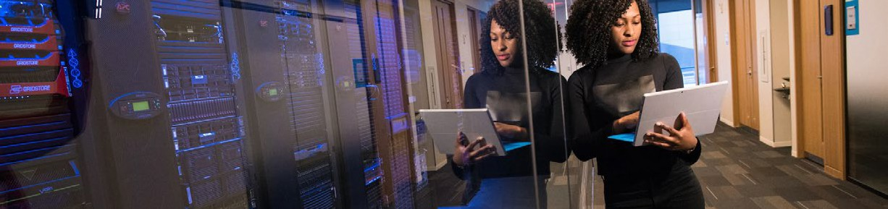

# Contract Vehicles

DEOS

Contract No.

47QTCA21A0003

Solutions Microsoft Office Eligible Users DoD

[Website](https://minburntech.com/microsoft-deos/)

SEWP V

Contract No.

NNG15SD34B

Solutions

Multi-vendor hardware and software

Eligible Users

Executive agencies and other authorized users [Website](https://www.sewp.nasa.gov/sewp5public/contractholders%23/detail/126)

GSA Schedule

Contract No.

GS-35F-309AA

Solutions

Microsoft licenses and cloud computing solutions Eligible Users

Executive agencies, SLED

and other authorized users

[Website](https://www.gsaelibrary.gsa.gov/ElibMain/contractorInfo.do?contractNumber=GS-35F-309AA&contractorName=MINBURN%2BTECHNOLOGY%2BGROUP%2C%2BLLC&executeQuery=YESmicrosoft-deos/)

DoD ESI

Contract No.

N6600119A0006

Solutions

Microsoft licenses and cloud computing solutions Eligible Users

DoD

[Website](https://www.esi.mil/ContentView.aspx?Id=969)

Administrative Information

### CAGE: 66LV8

UEI: WN8JFVZTBCA5

Principal NAICS: 541519 (IT VAR)

Size Status: Small

Socieo-economic Status: Service-Disabled, Veteran-Owned Small Business (CVE-Verified)

# Corporate Information

Corporate Address: 9716 Arnon Chapel Road, Great Falls VA 22066

Remittance Address: PO Box 1227, Great Falls VA 22066

[info@minburntech.com](mailto:info@minburntech.com)

(571) 699-0705 (phone)

(703) 738-7720 (fax)